id

001 MapActivityOnKeyDown

002 MapActivityOnKeyUp

003 MapActivityOptionsMenuClicked

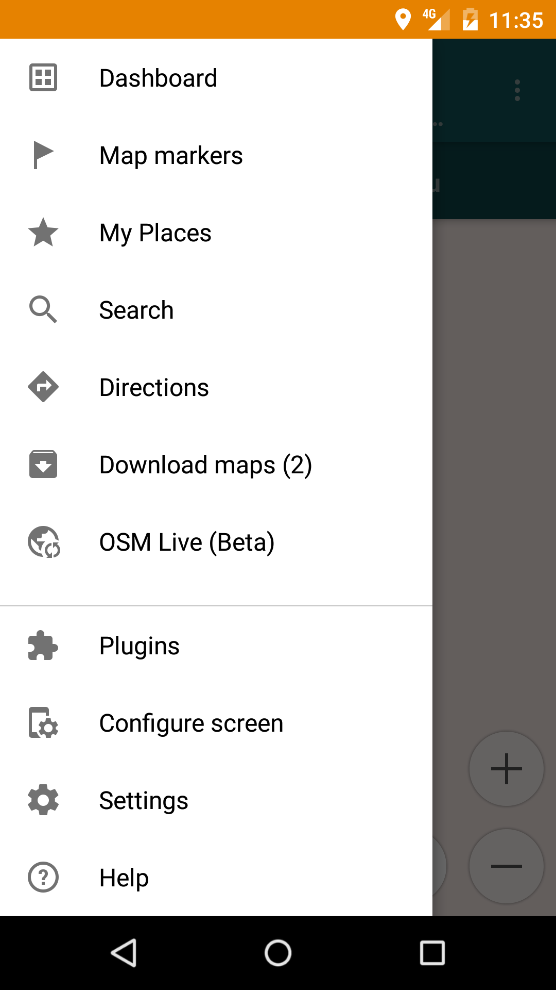

004 MapActivityOnLongPressed

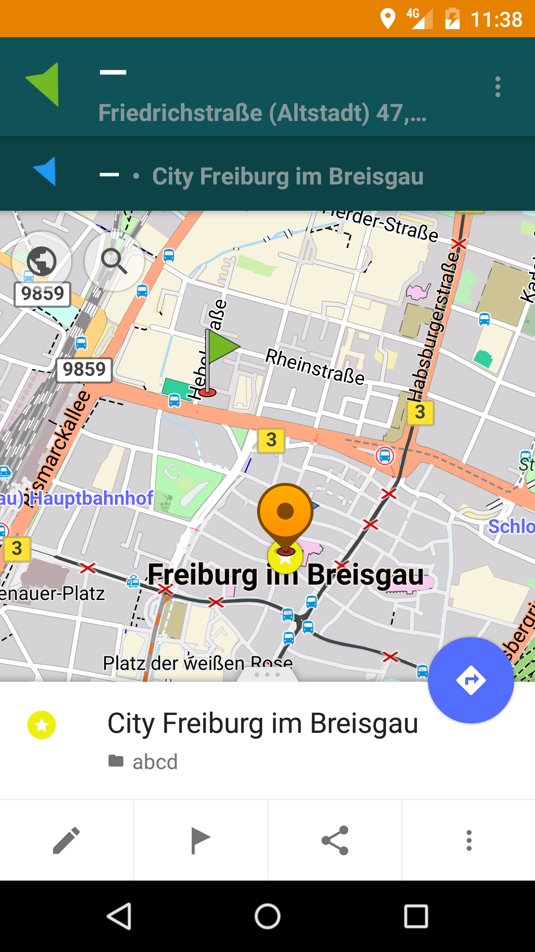

005 MapContextMenuAddFavoriteInfo

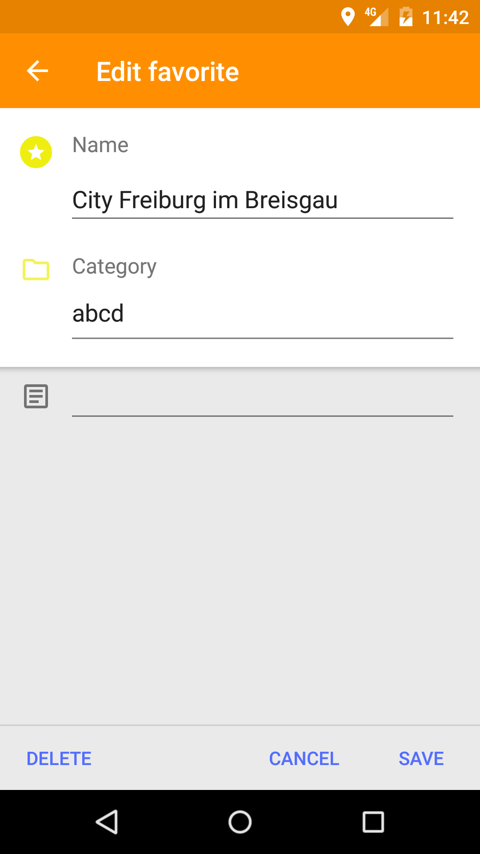

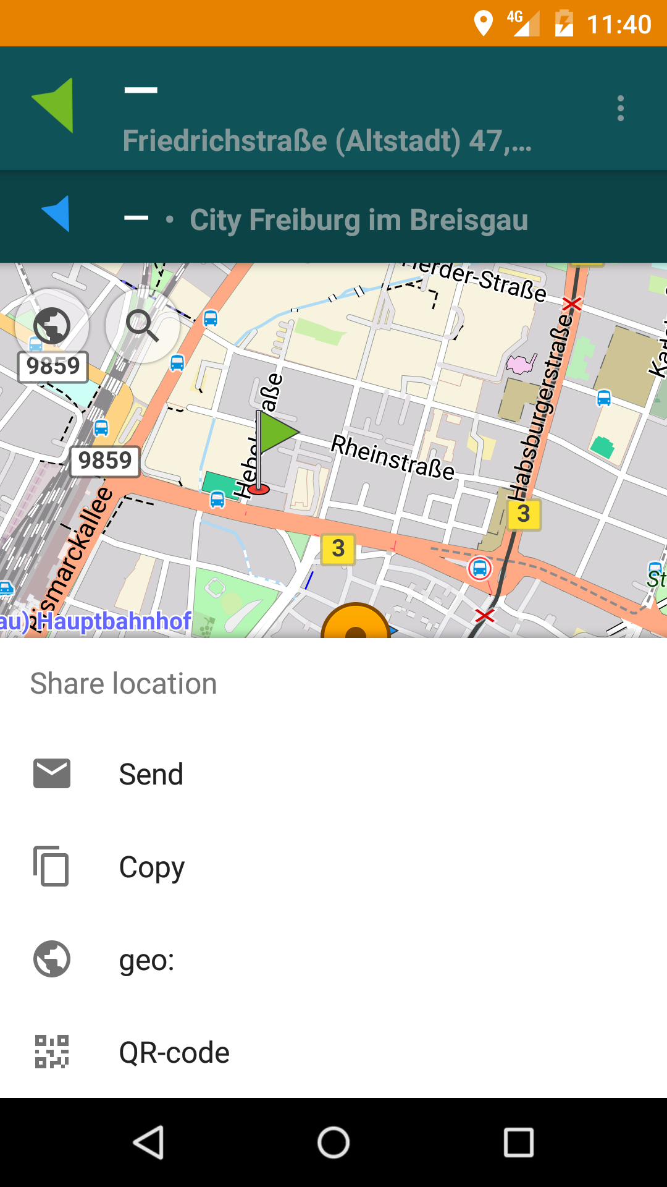006 MapContextMenuShareInfo

MapMarkers

021 MapMarkersActiveItemsClicked

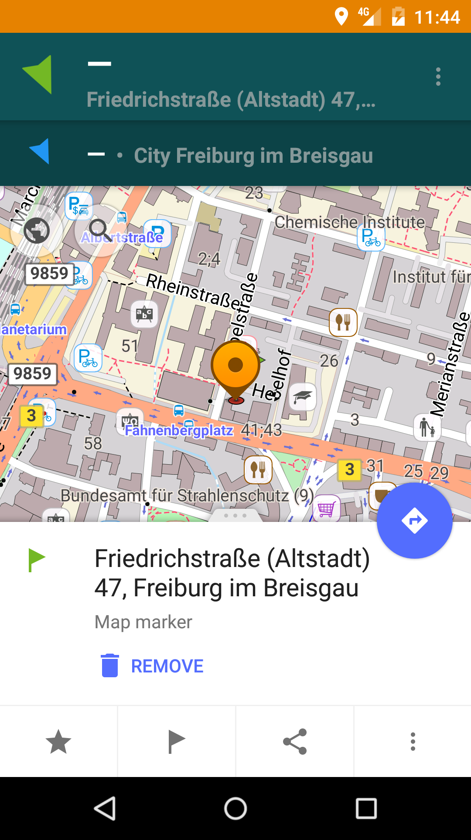

022 MapMarkersDoRoute

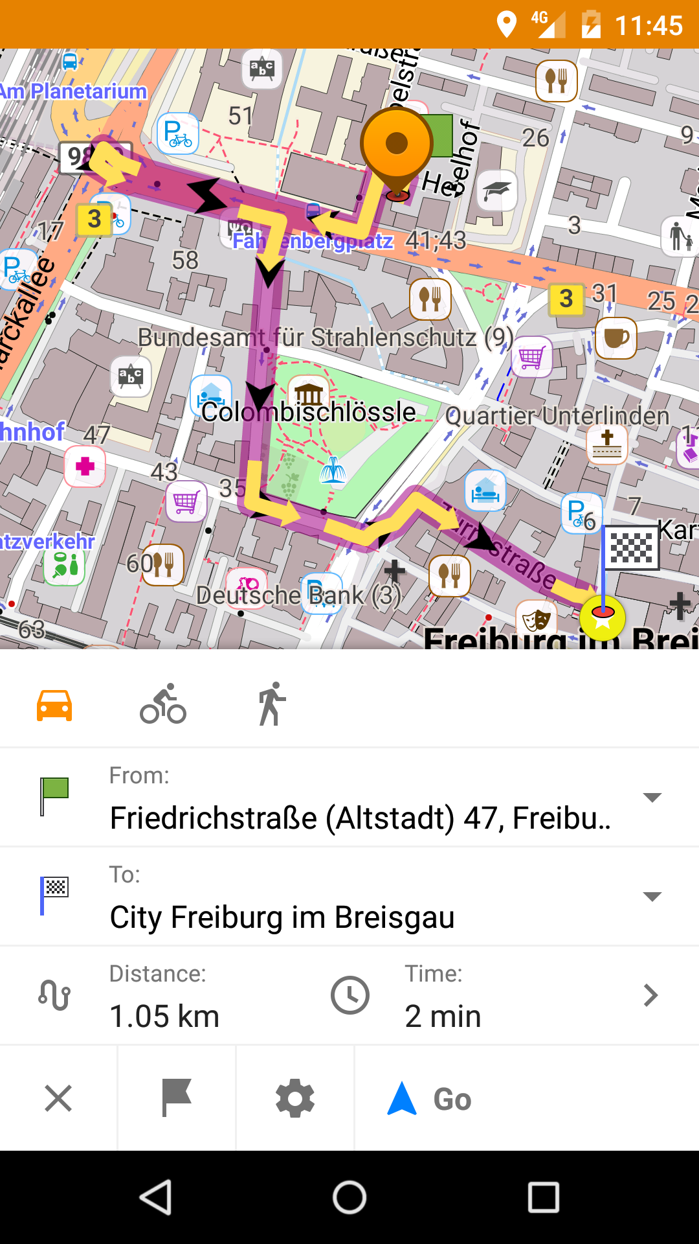



024 MapMarkersSaveGPX

MyPlaces

031 MyPlacesMyFavouriteGroup

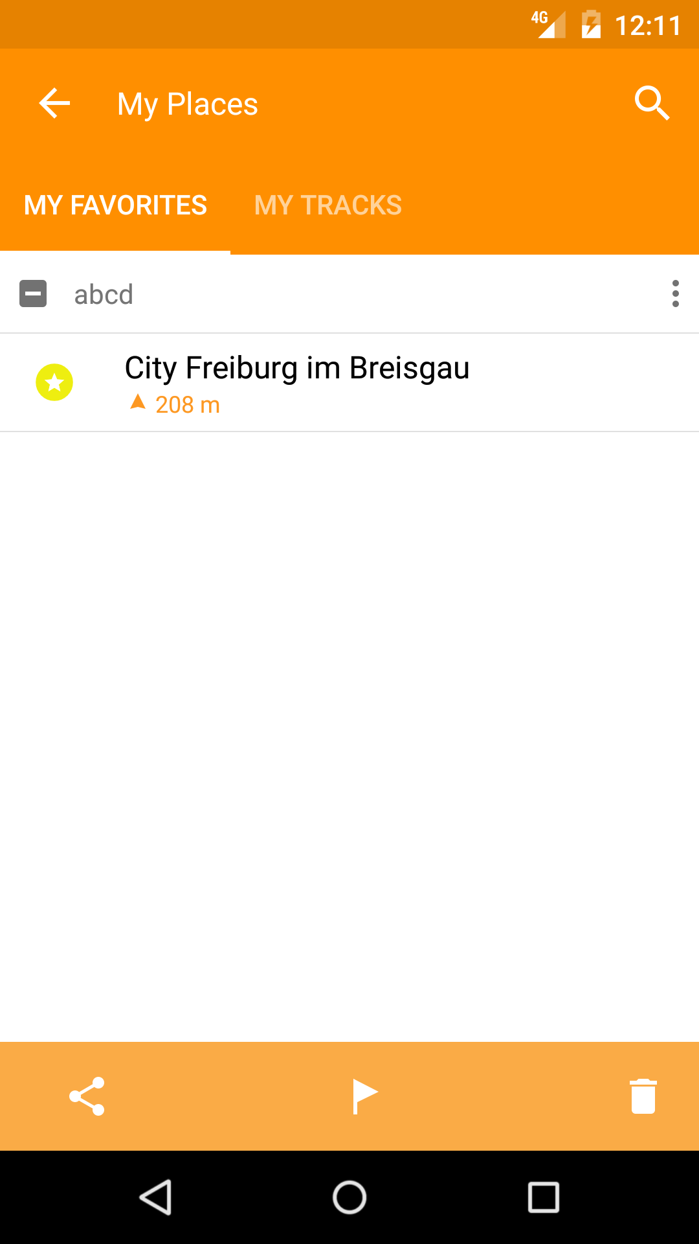

032 MyPlacesMyFavouriteSearchInput

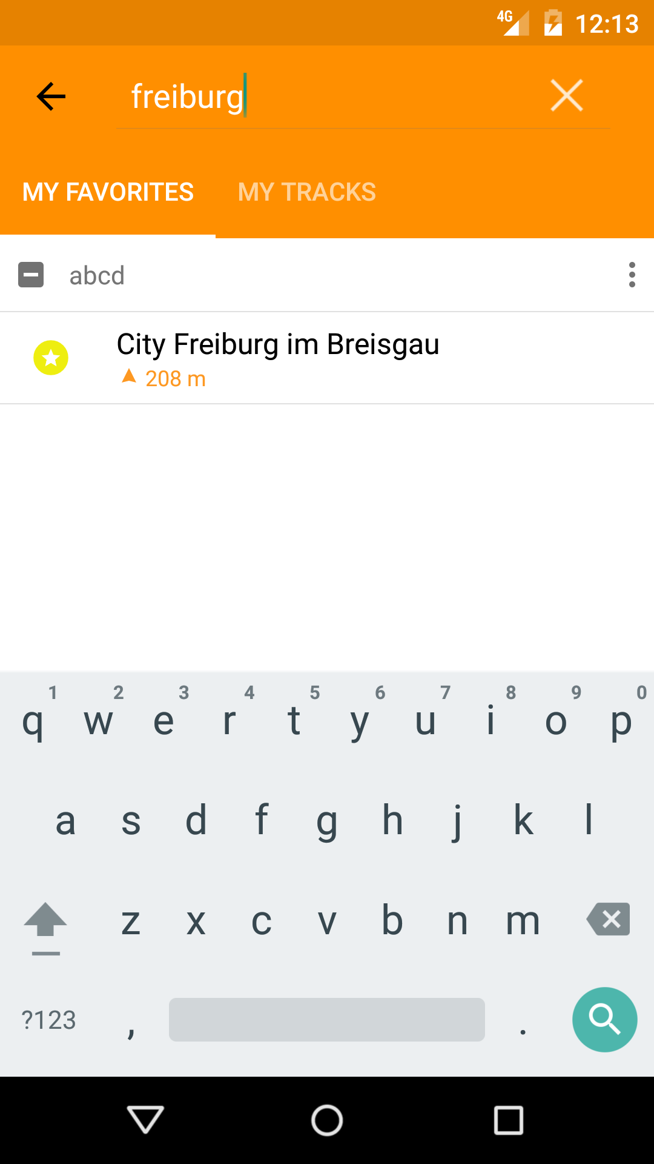

033 MyPlacesMyFavouritePOIClicked



034 MyPlacesMyFavouriteGroupNameEdited

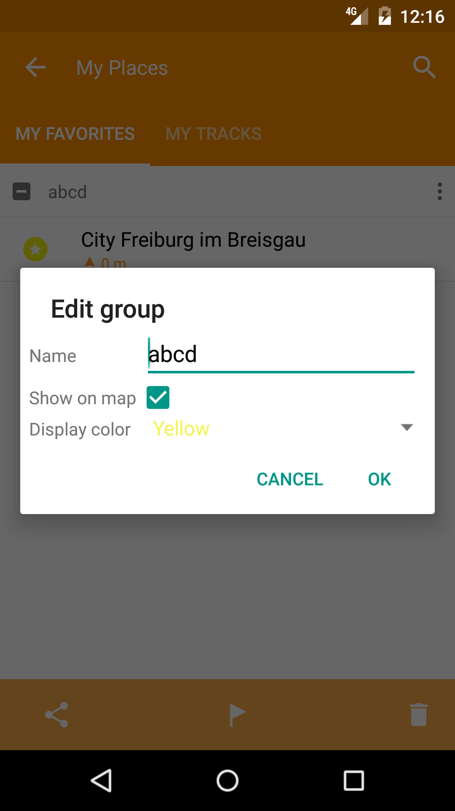

035 MyPlacesMyTracksFileName

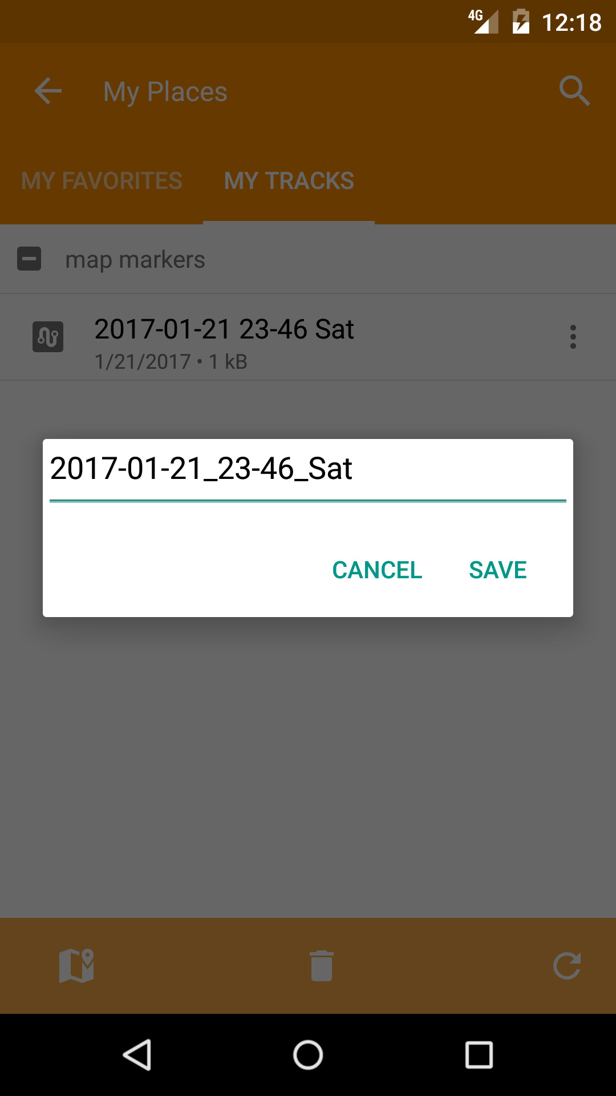

036 MyPlacesMyTracksShare

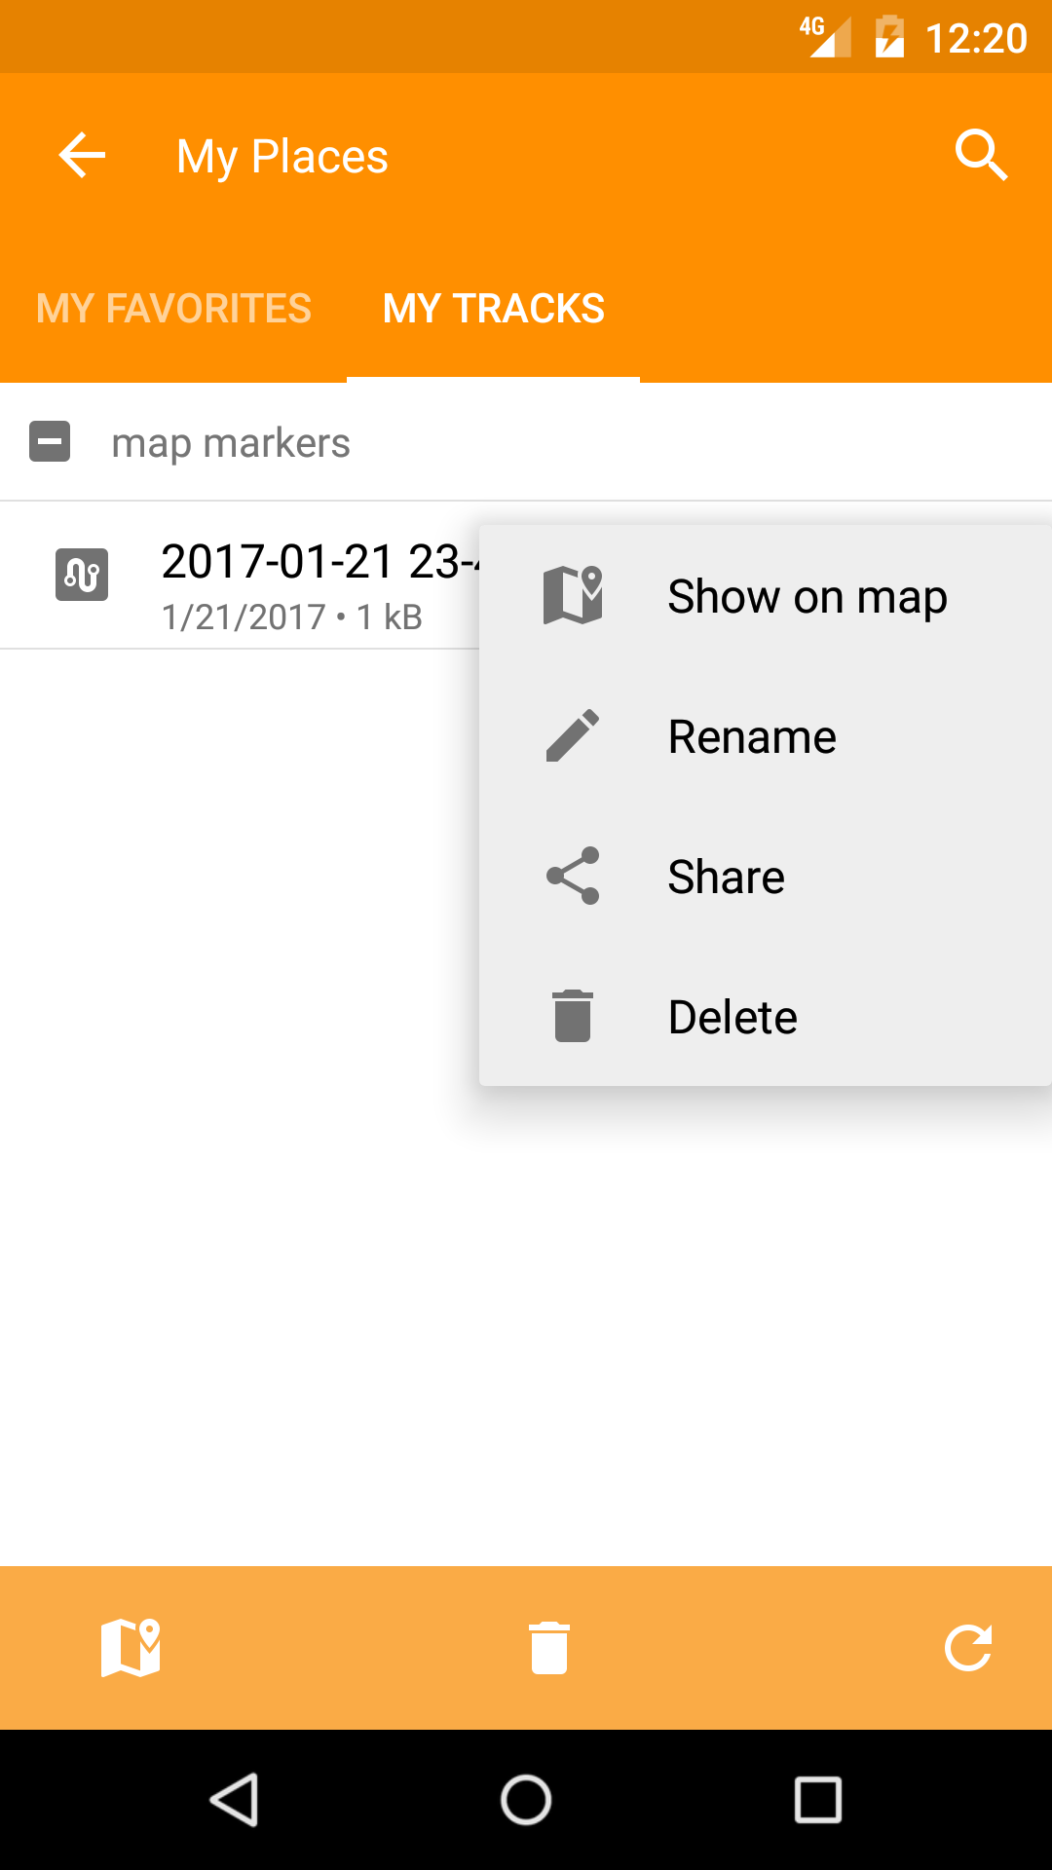

037 MyPlacesMyTracksSearchInput

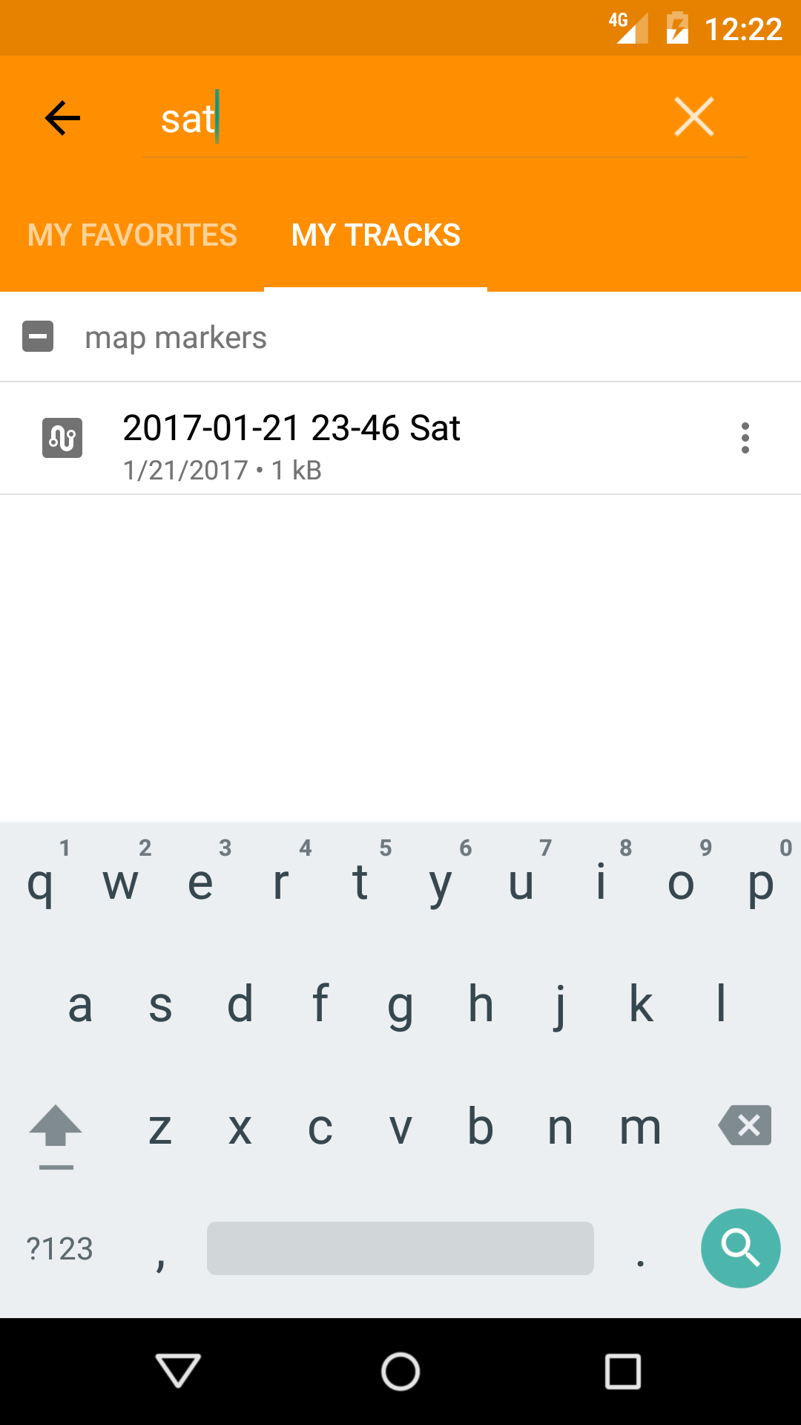

Search

041 SearchInput

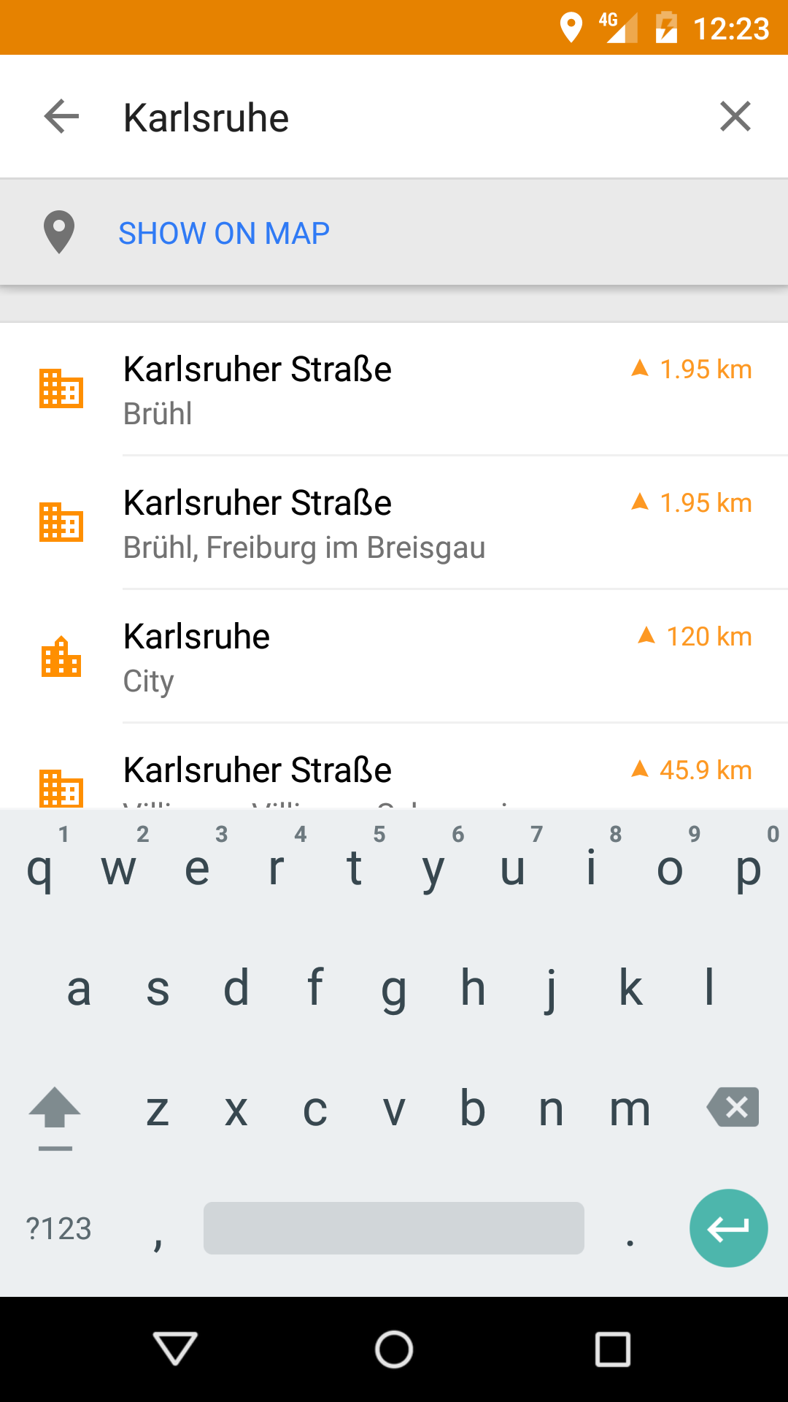

042 SearchResultItemClick

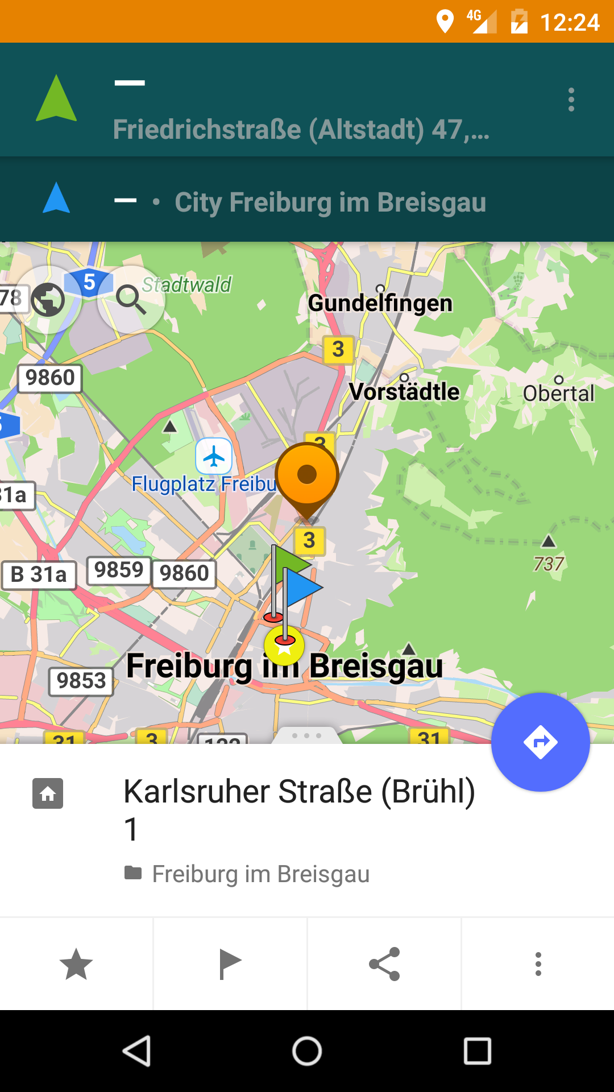

043 HistoryShare

Directions/Routing Monitoring

051 RoutingParams



052 RoutingInfo

053 TrackShare

DownloadMap

061 DownloadMapItemDownload

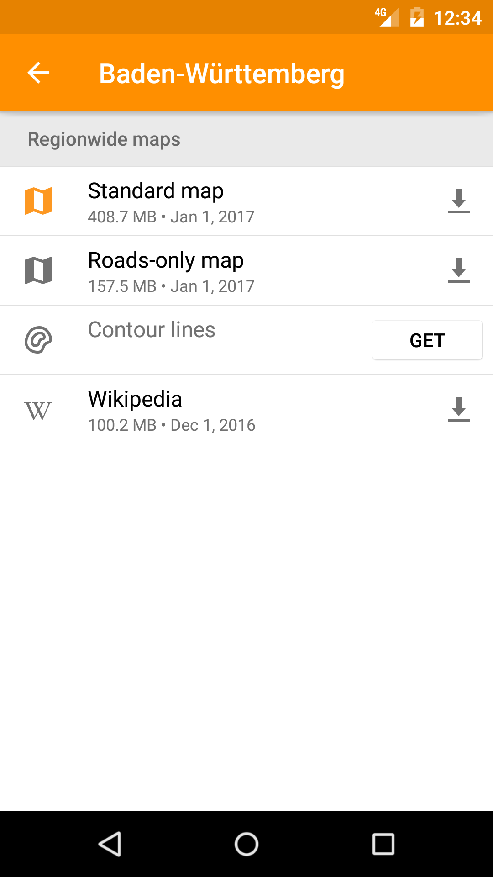

062 DownloadMapItemRename

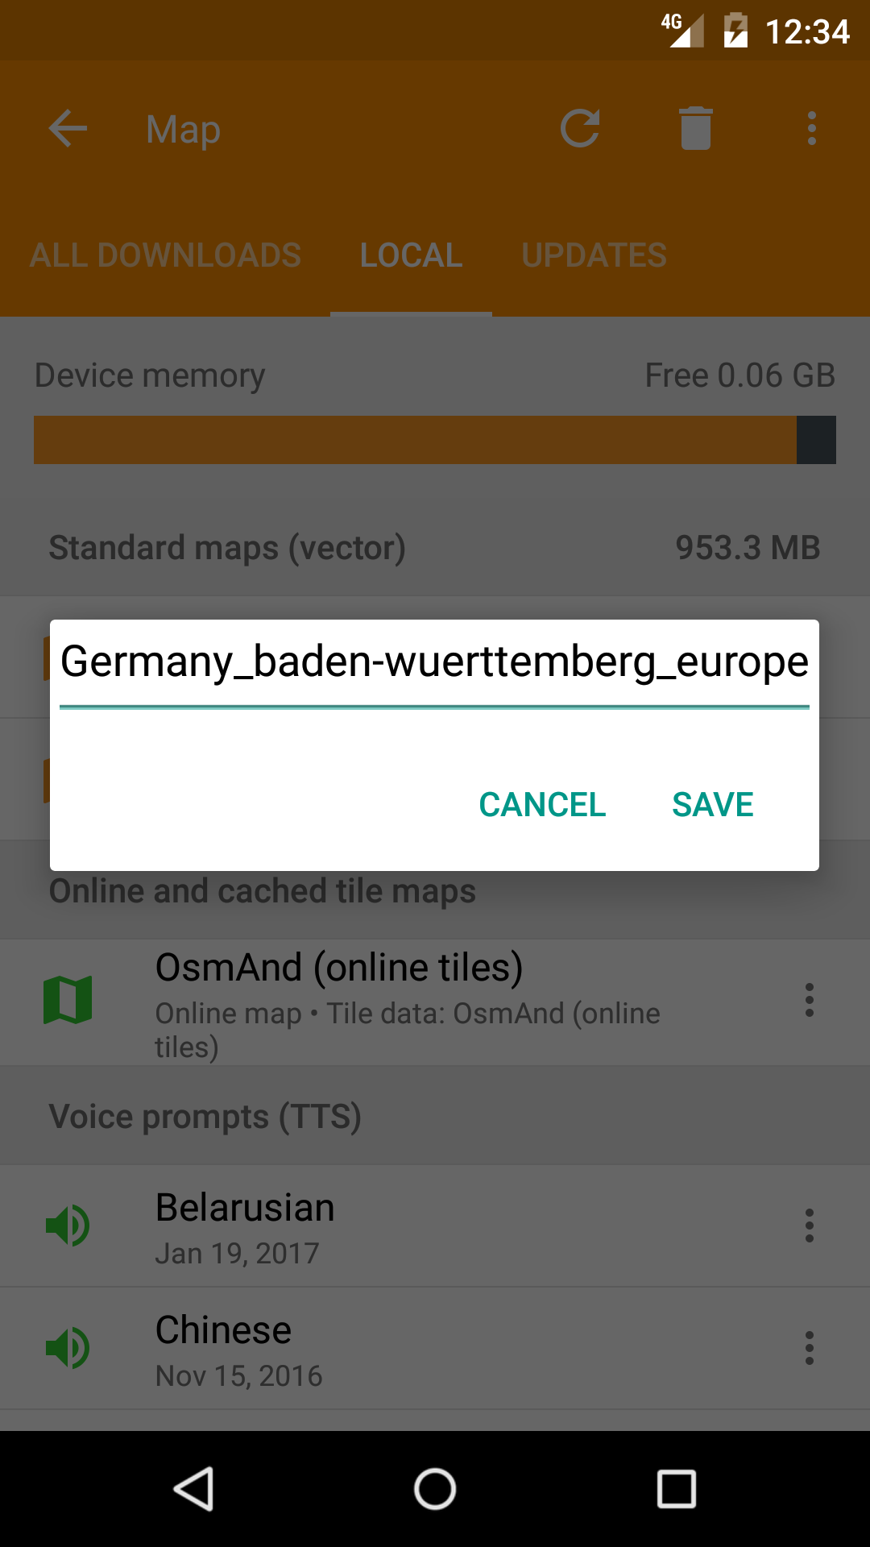

OSM Live

071 OSMLiveItemSettings

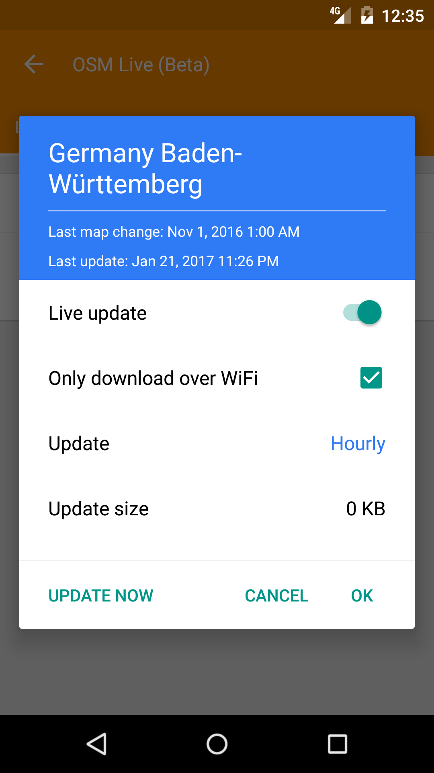

072 OSMLiveSubscriptionParams

Configure Screens

???

Settings

081 SettingsGerneralChangedInfo

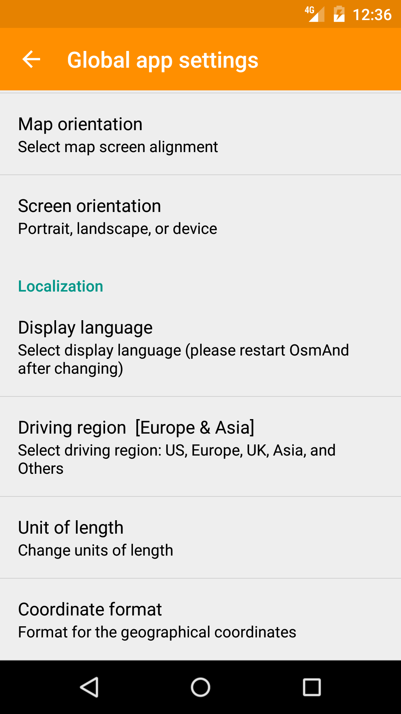

082 SettingsNaviChangedInfo

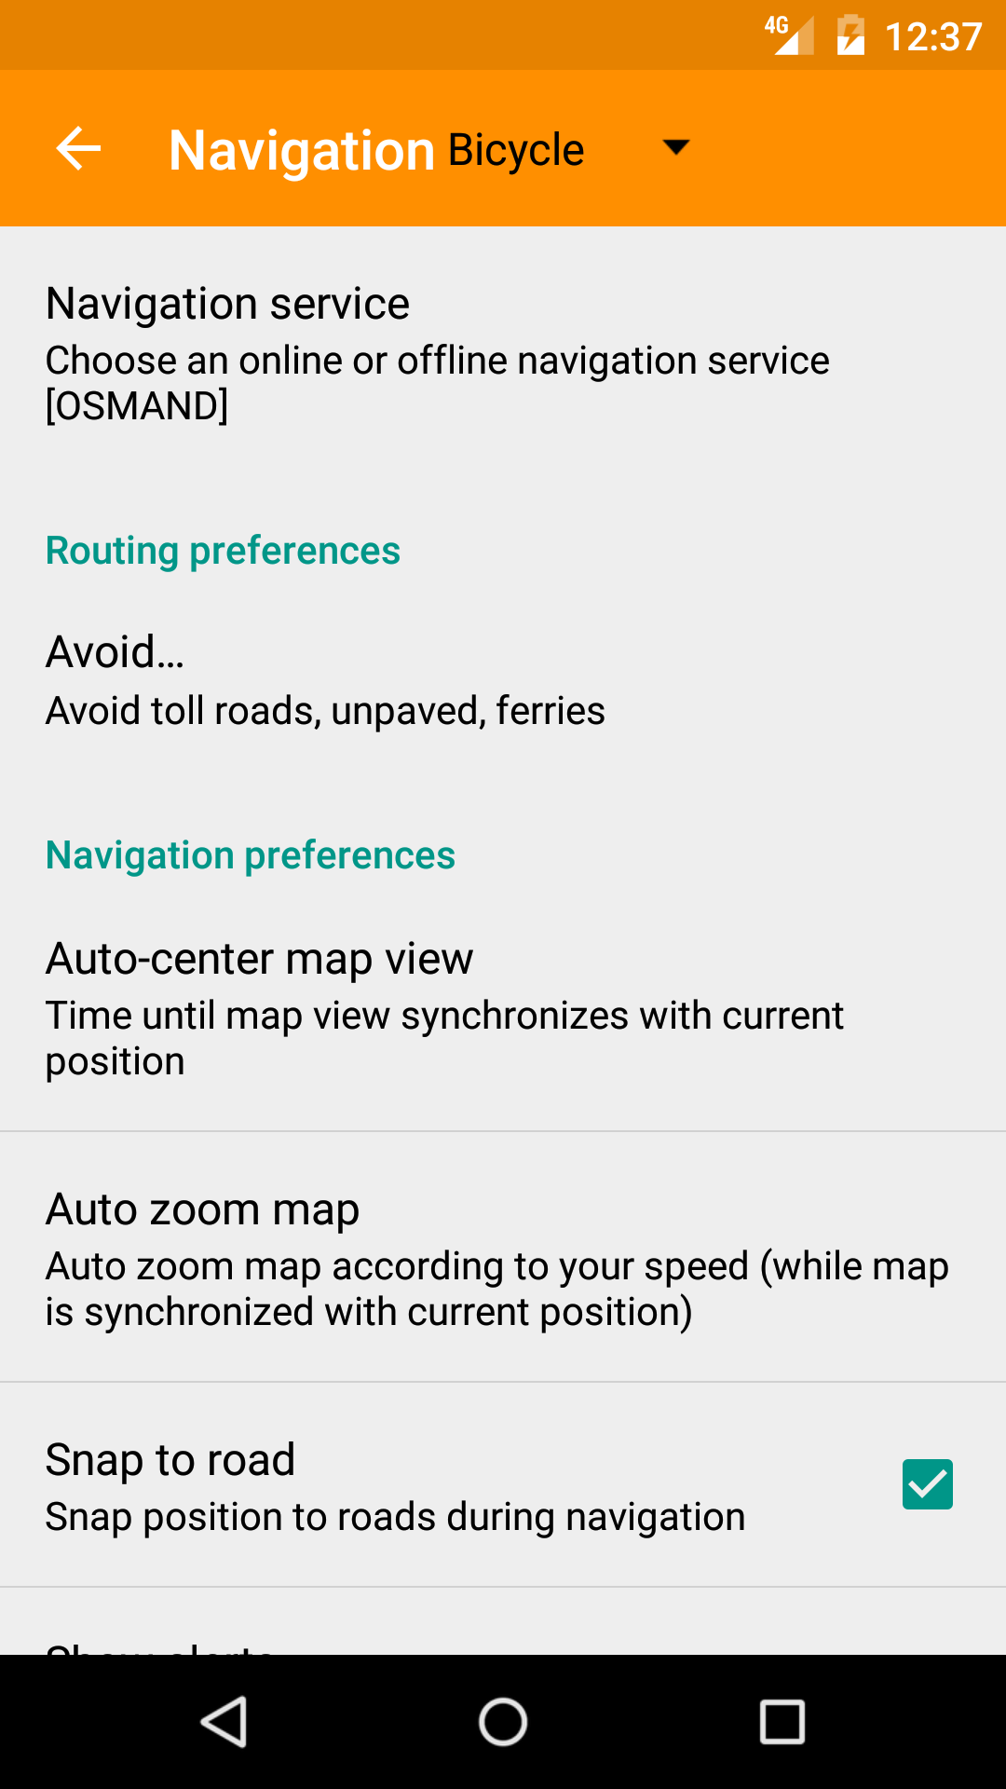

Help

???

FileActions

Load

0A1 GpxLoadInfo as "TrackGpxInfo","PointGpxInfo","RouteGpxInfo","HistoryEntriesGpxInfo" marked

Save

0A2 GpxLoadInfo as "TrackGpxInfo","PointGpxInfo","RouteGpxInfo","HistoryEntriesGpxInfo" marked